**Important Instruction:**

1.Please read the document thoroughly before you code.

2.Import the given skeleton code into your Eclipse.

3.You have to create the input file for the methods.

4.Refer/Use the solution file only when you are not able to complete the case study within 1 hours

A Retail shop wanted to maintain the details of the products sold for a particular date. For this they want to organize the data in such a way that there should be two output files one containing the unique records while the other contain the duplicate records.

**Skeleton File for Development:**

Import the below attached skeleton code into your eclipse project and implement the required functionalities



**Requirements:**

**Develop an application for the below 2 requirements.**

**Requirement 1:**

Read records from the input file and write down the record in two separate file .Unique records (any one of the fields of the record is not identical) will be put in one file while the duplicate records (all the fields of the record are identical) need to be put in a separate file.

**Requirement 2:**

Validating the input data.

Validations to be done:

1. All fields are mandatory.
2. The length of the ProductId field should be 11.

If any of the above two validations fails, the system should throw a user defined exception “**RetailShoppingException**”.

**Technical Specifications:**

|  |  |  |  |  |
| --- | --- | --- | --- | --- |
| **ClassName** | **Method Name** | **Input Parameters** | **Sample Input** | **Output Parameters** |
| RetailShoppingOrganizer | processProductDetails | **String filePath** – path of the folder along with the filename where the data feed is located. | **"C:\\data\\retails.txt"** | **void** |
| RetailShoppingOrganizer | validateProductDetails | **String[] inputdata** all the fields of the file | **QA-424515,Arun,5,03-31-2012,10000** | **void** |

**Input File:** Create an input file with the name “**retails.txt”** and store the sample product details records(each line is a record). Use the delimiter “,” to separate the field values.

The record format is given below

**ProductId,CustomerName,QuantityPurchased,DateOfPurchase,TotalCost**

Field Constraints:

**ProductId –** UniqueCode to identify the product.

**Name** – Name of the Customer.

**QuantityPurchased** – Quantity of product purchased.

**DateOfPurchase --** Date of purchase.

Format of the **ProductId** is **QA-**12424515. (First 2 character should be alpha numeric followed by hyphen followed by 8 digit number).

Sample Input File:

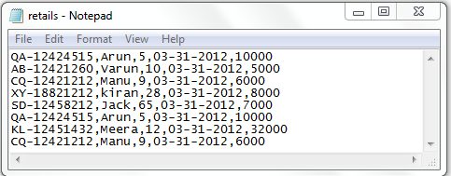

**Sample Output File 1:** For Unique Records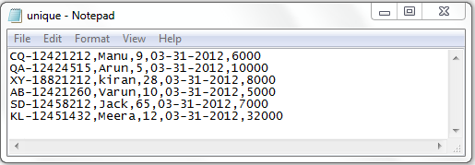

Sample Output File 2 : For duplicate Records

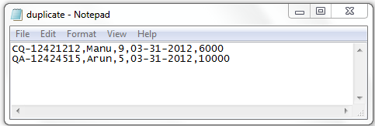

1. **Solution:**

**The attached code is one of the possible solution meeting the given requirement. Please refer/use this only if you are not able solve the above given problem scenario within 1 hours.**

